**Lesson Notes**

1. What is the main purpose of an Operating System?

Simpler / More Efficient Application Programs

* Operating System handles the Computer Hardware
* Operating System handles resource allocation

Consistent User Experience

* Operating System provides a standard User Interface (Windows)
* Operating System provides a standard way to store and browse data files and folders (File Explorer)

Allow Multiple Applications Running At Same Time

* Operating System Provides Ownership Control (User Accounts)
* Operating System Schedules the CPU (Task Sharing)

1. What is the difference between Operating System Software and Use Application Software?

User Interface

* + Applications focus on what is contained and displayed within a window
  + Operating System controls opening / closing / resizing windows and responding to mouse and keyboard actions
  + Operating System provides standard ways to print, save and open files, access the internet, etc.

Resource Allocation

* + Applications just ask for what they need (e.g. Memory, Disk Space)
  + Operating System checks for availability and access permission
  + Operating System coordinates resource allocation between applications

1. What is the difference between Operating System Software and Computer Hardware?
   * Same applications can run on different computer hardware
   * Operating System must be configured according to hardware components present in the computer
2. What are the main parts of an Operating System?

* Graphical User Interface (GUI)
  + Windows Display, mouse, keyboard, sound, etc.
* System Calls
* Device Drivers
* I/O Manager
* Memory Manager
* Process Manager
* Security Monitor

1. What are some popular operating systems?

* Windows OS
* Mac OS
* Linux / Unix
* Android
* iOS

**Reference Diagram**

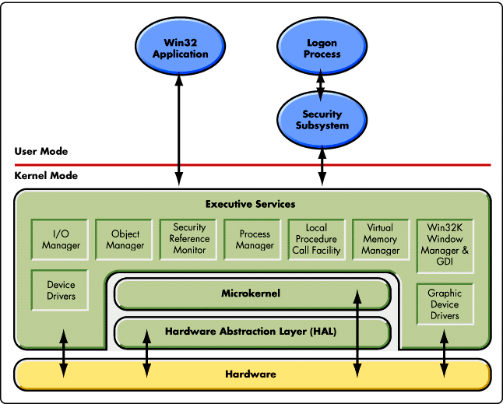

**Student Questions**

1. What is a device driver?
   1. Provide a brief summary

**A device driver is a file that lets the computer know the configuration and specifications of a certain hardware device**

* 1. List some devices that require a device driver.

**hard drives, DVD drives, and PCI cards require a device driver. Without the driver file, the computer will be unable to communicate with the device**.

* 1. Provide a label on the reference diagram for the location of a device driver for your graphics card.

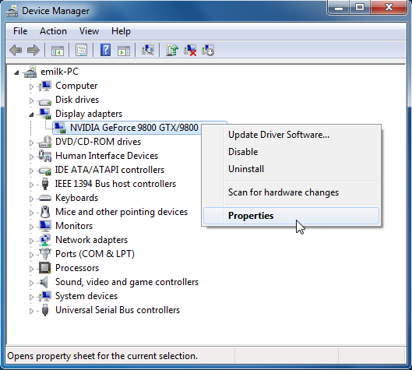

* 1. Provide a label on the reference diagram for the location of a device driver for a locally attached printer.

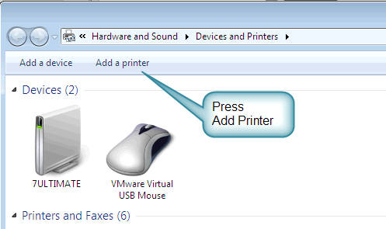

1. What is a DLL?
   1. Provide a brief summary

**DLL files are for developers to use shared code and data, allowing to upgrade functionalities without the need to re-link or re-compile application**

* 1. Explain how DLLs are related to user application programs  
     **in Windows operating systems, the Comdlg32 DLL performs common dialog box related functions.**
  2. Provide a label on the reference diagram for the location of a DLL

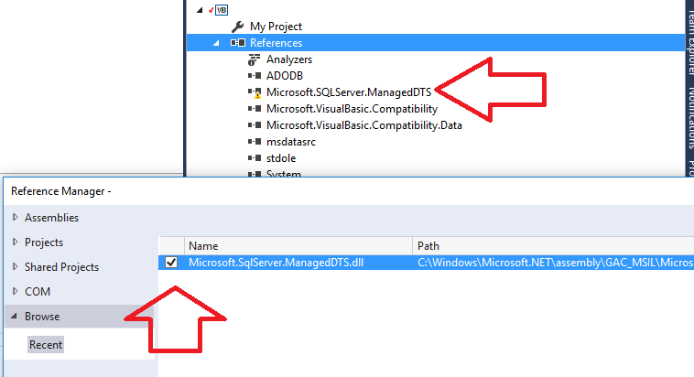

1. What is a windows manager?
   1. Provide a brief summary

**A window manager is system software that controls the placement and appearance of windows within a windowing system in a graphical user interface**

* 1. Explain how a windows manager is related to user application programs

**It is related since it allows the user to view multiple windows at a time, it is very efficient.**

* 1. Provide a label on the reference diagram for the location of a DLL

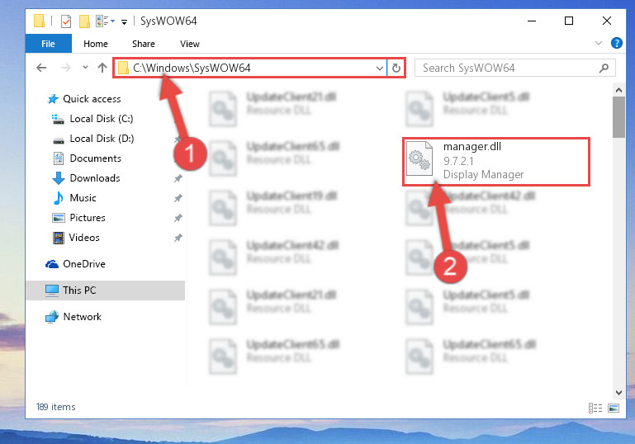

1. What is the windows task manager?
   1. Provide a brief summary

**Windows Task Manager enables you to monitor the applications, processes, and services currently running on your PC. provides details about programs and processes running on your computer.**

* 1. List and explain four (4) types of system information provided by the task manager
* CPU storage
* Memory usage
* Disk usage
* Network usage
  1. Provide a label on the reference diagram for the operating system components related to each type of information.

